Laser Game Report

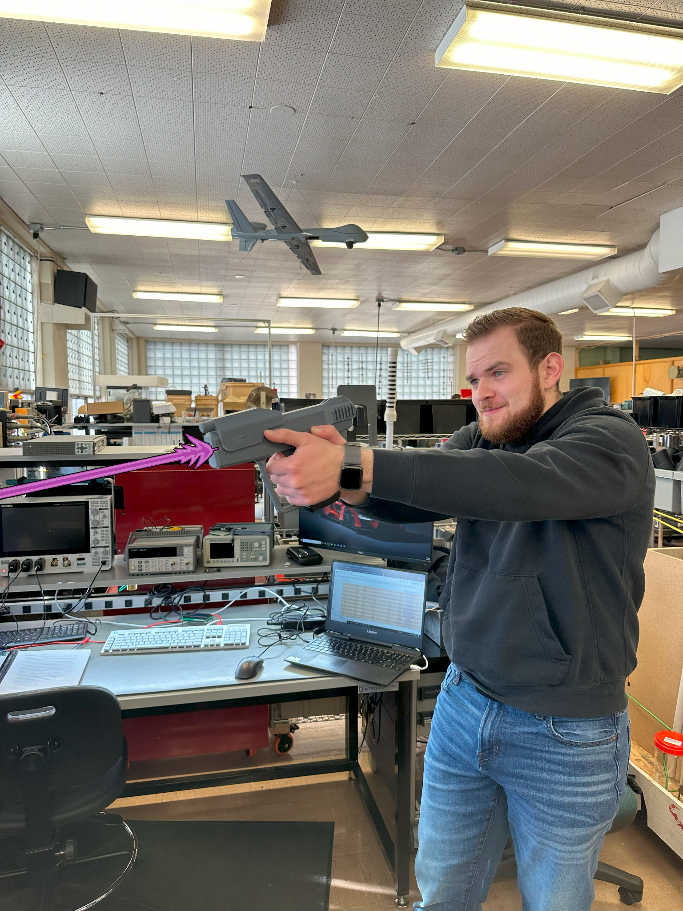

Alex Wheelock

Robotics and Communications Systems Engineering Technology, Idaho State University

RCET 3375: Advanced Computer Architecture and Embedded Systems Laboratory

Instructor: Shane Slack

December 11, 2024

# Table of Contents

Table of Contents 2

Table of Figures 3

1: Abstract 5

2: Background 6

3: Proposed Problem 7

3.1: Overview 7

3.2: Semester Goals 8

4: Blaster 9

4.1: Blaster Overview 9

4.2: Blaster Circuit Description 10

4.2.1: Laser Output 10

4.2.2: PWM Frequency Select 11

4.2.3: Fire Mode Select 13

4.2.4: Solenoid Output 16

4.3: Blaster Troubleshooting 17

5: Target System 21

5.1: Target System Overview 21

5.2: Target Master Circuit Description 22

5.2.1: I2C Communication 22

5.2.1.1: Enabling a Target 22

5.2.1.2: Reading a Slave’s Status 22

5.3: Target Slave Circuit Description 23

5.3.1: Overview 23

5.3.2: Target Enable 23

5.3.3: Target Reception 24

7: Engineering Log 25

8: Cost Analysis 27

9: Conclusion 31

9.1: Recommendations 31

10: Appendix A (Schematics) 33

11: Appendix B (Flowcharts) 42

12: Appendix C (Port Bitmaps) 45

13: Appendix D (Code) 47

13.1: Blaster Assembly Code 47

13.2: Blaster Subroutine Assembly Code 49

13.3: Blaster Setup Assembly Code 52

14: Appendix E (GitHub) 57

# Table of Figures

Figure 1.1: Laser Game Block Diagram 5

Figure 3.1.1: Nerf Arcade Project 7

Figure 4.1.1: Blaster Breadboard Layout 10

Table 4.2.1: PWM Frequency Select Truth Table 11

Figure 4.2.1: 38kHz PWM Output Frequency Waveform Capture (RB1 = 0) 12

Figure 4.2.2: 56kHz PWM Output Frequency Waveform Capture (RB1 = 1) 12

Table 4.2.2: Fire Mode Select Truth Table 14

Figure 4.2.3: Semi-Auto Fire Mode Waveform Capture (RB2 = 0, RB3 = 0) 14

Figure 4.2.4: Burst-Fire Fire Mode Waveform Capture (RB2 = 0, RB3 = 1) 15

Figure 4.2.5: Full-Auto Fire Mode Waveform Capture (RB2 = 1, RB3 = 0) 15

Figure 4.3.1: Troubleshooting Flowchart 17

Table 5.2.1: Truth Table for Slave Read Byte 23

Table 7.1: Alex Wheelock’s Project Engineering Log 25

Table 8.1: Blaster Bill of Materials 27

Table 8.2: Target Master Bill of Materials 28

Table 8.3: Target Slave Bill of Materials 29

Table 8.4: Labor Bill of Materials 30

Table 8.5: Project Build Cost 30

Table 8.6: Project Total Cost 30

Figure 10.1: Blaster Main Schematic Sheet 33

Figure 10.2: Blaster Power Schematic 34

Figure 10.3: Blaster Circuit Schematic 35

Figure 10.4: Target Master Main Schematic Sheet 36

Figure 10.5: Target Master Power Schematic 37

Figure 10.6: Target Master Circuit Schematic* 38

Figure 10.7: Target Slave Circuit Schematic* 39

Figure 11.1: Blaster Program Flowchart 40

Figure 11.2: Target Master Program Flowchart* 41

Figure 11.3: Target Slave Program Flowchart* 42

Table 12.1: Blaster PORTA Bitmap 43

Table 12.2: Blaster PORTB Bitmap 43

Table 12.3: Blaster PORTC Bitmap 43

Table 12.4: Target Master PORTA Bitmap 43

Table 12.5: Target Master PORTB Bitmap 43

Table 12.6: Target Master PORTC Bitmap 44

Table 12.7: Target Slave PORTA Bitmap 44

Table 12.8: Target Slave PORTB Bitmap 44

Table 12.9: Target Slave PORTC Bitmap 44

Figure 14.1: GitHub Laser Game Project Repository 55

# 1: Abstract

The Laser Game project is a game that will be used for recruiting purposes for Idaho State University’s Robotics and Communications Systems Engineering Technology program. This project has two components, the blaster and the target system. It has two laser blasters that will allow two players to compete against each other, engaging targets for points. Each blaster’s laser pulses at a different frequency, allowing IR receivers to determine who shot the target. Targets will randomly enable, and light up to tell the players which target to shoot. Each target shot gives a point for the player who shot it first, and the player with the most points at the end wins.

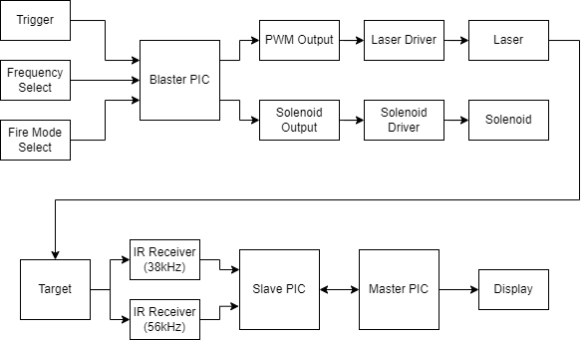

##### Figure 1.1: Laser Game Block Diagram

# 

# 2: Background

Though there is no previous work on this project, this project is being designed and built from the ground up in the Fall 2024 semester. However, the Laser Game project is being developed to replace a similar project from the past which was Nerf based, rather than laser based.

# 3: Proposed Problem

## 3.1: Overview

In the past, the ISU Robotics program has used motor driven Nerf gun turrets controlled by game controllers (Shown in Figure 3.1.1), however there are some drawbacks to the Laser Game’s predecessor. First, the balls that the Nerf guns shoot need to be picked up and the guns need to be reloaded which lead to downtime that the game cannot be played. In response to this, a robot was designed to pick up the shot Nerf balls inside the netted area to reduce the downtime. However, this robot does not currently work. The second issue is that the motors which control the turrets were damaged and also no longer work. The Laser Game is being developed to eliminate the need for cleanup and downtime, and create an improved game for recruiting with better reliability compared to its predecessor.

Image provided by Shane Slack

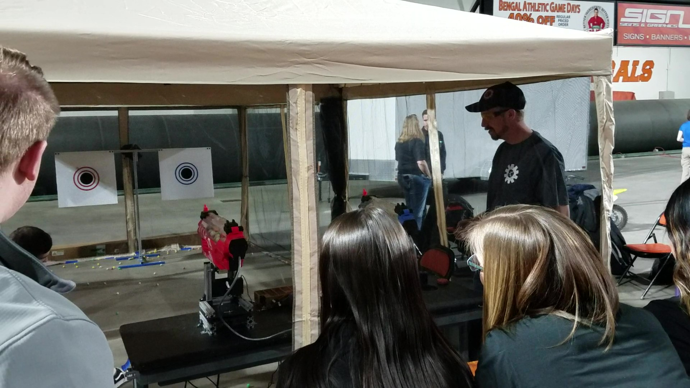

##### Figure 3.1.1: Nerf Arcade Project

## 3.2: Semester Goals

The goals for this semester on this project were to get a base of the project laid out, and develop as much as possible within the given project time of the semester, focusing on the programming. Specific goals included:

1. Design and develop a prototype for the blasters.
2. Get the blasters working so that they are able to trigger different IR receivers.
3. Come up with an idea of how the game will function, and all parts necessary for the project.
4. Design and develop the target circuits, so that the game functions as intended.

# 4: Blaster

## 4.1: Blaster Overview

The blaster is the device used by the players to engage targets and score points. The blaster has 4 digital inputs, and 2 digital outputs. The inputs are: a fire switch, a frequency select switch, and a fire-mode select switch. The outputs are: the PWM output which controls the laser, and a solenoid which is energized in tandem with the laser. The laser is driven by the PWM so that it can pulse at the player specific frequencies (38kHz & 56kHz), corresponding to the IR receiver frequencies at the targets on the slave. The solenoid output will be used to simulate the recoil and cycling of the slide as felt on a real pistol.

The software and hardware of the blaster are completed. However, there is currently no PCB designed, nor is there a gun to mount the future PCB and hardware into. The working prototype on a breadboard can be seen below in Figure 4.1.1: Blaster Breadboard Layout. The schematic for the blaster can be found in Figure 10.3: Blaster Circuit Schematic in Appendix A (Schematics). The code for the blaster can be found in Appendix D (Code), and the port bitmaps can be found in Appendix C (Port Bitmaps), tables 1-3.

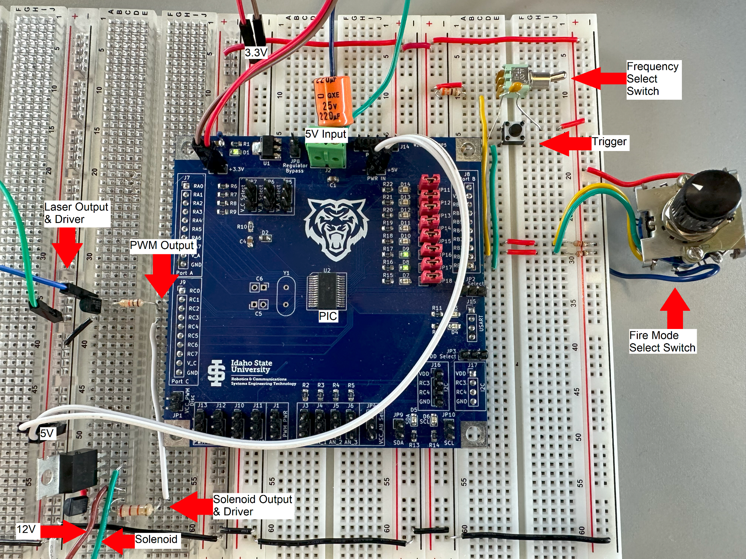

##### Figure 4.1.1: Blaster Breadboard Layout

## 4.2: Blaster Circuit Description

### 4.2.1: Laser Output

The laser used is a simple laser diode with two wires, and a built-in regulator which requires 5V to turn on the laser. The breadboard circuit used a PIC development board which was equipped with a PIC16LF1788 which takes 3.3V, and thus an output driver using a BJT as a switching transistor was used to provide the necessary 5V for the laser. The final product will use the PIC16F1788 to reduce the amount of linear regulators required for the circuit, also reducing the need for an output driver for the laser. The PIC16F1788 is capable of ±50mA, and the laser was measured to pull 26mA, making it safe for the PIC to drive on its own.

The laser output is driven by the PWM output of the PIC’s Capture and Compare Module 1 (CCP1) on RC2. CCP1 is used to pulse the laser at the frequencies of 38kHz or 56kHz, which corresponds to the IR receiver frequencies, and are how the target is able to differentiate between the two players. The PWM output is always running but under normal conditions the TRISC bit is set for RC2, disabling the output driver. Once the trigger button (SW1) is pressed on RB0, the laser will turn on, with a frequency of 38kHz or 56kHz as determined by the frequency selector switch (SW2) on RB1, and in 1 of 3 modes (semi-auto, burst-fire, or full-auto) as determined by the fire-mode selector switch (SW3) on RB2 and RB3. Regardless of the laser’s PWM frequency, the duty cycle of each frequency has been set to ~95% for maximum brightness of the laser for more power and a longer effective range, while still allowing the receivers to pick up the frequencies.

### 4.2.2: PWM Frequency Select

The PWM output has two frequency options, 38kHz and 56kHz. The frequency is selected by the frequency selector switch, shown in the top right corner of Figure 4.1.1. The frequency selector switch is a SPST switch connected to RB1 labeled SW2. In the open position RB1 sees a logic low, and the PWM will operate at 38kHz. When closed RB1 sees a logic high, the PWM will operate at 56kHz. See the truth table in Table 4.2.1 below, as well Figures 4.2.2.1 and 4.2.2.2 for waveform captures detailing this relationship.

##### Table 4.2.1: PWM Frequency Select Truth Table

| **SW2 Position** | **RB1** | **PWM Frequency** |
| --- | --- | --- |
| OFF | 0 | 38kHz |
| ON | 1 | 56kHz |

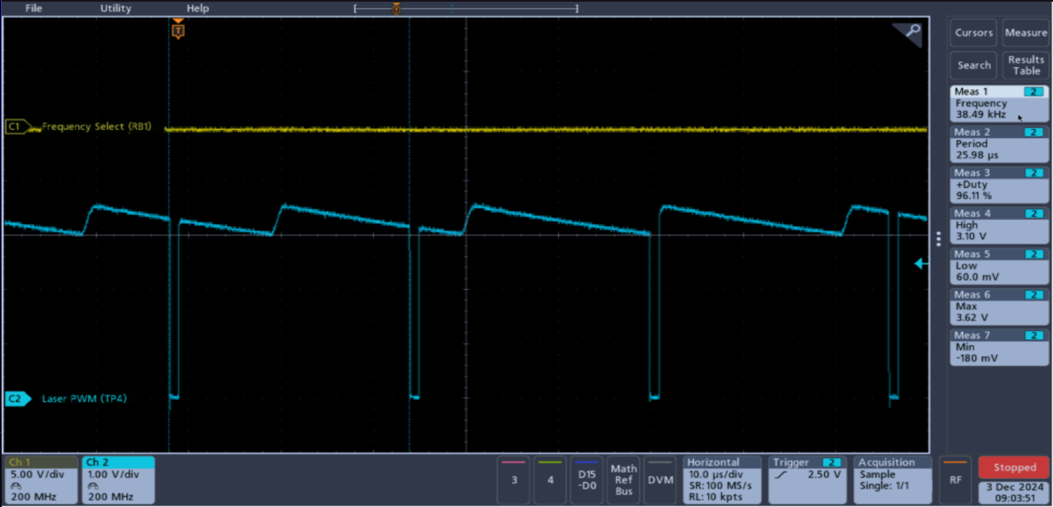

##### Figure 4.2.1: 38kHz PWM Output Frequency Waveform Capture (RB1 = 0)

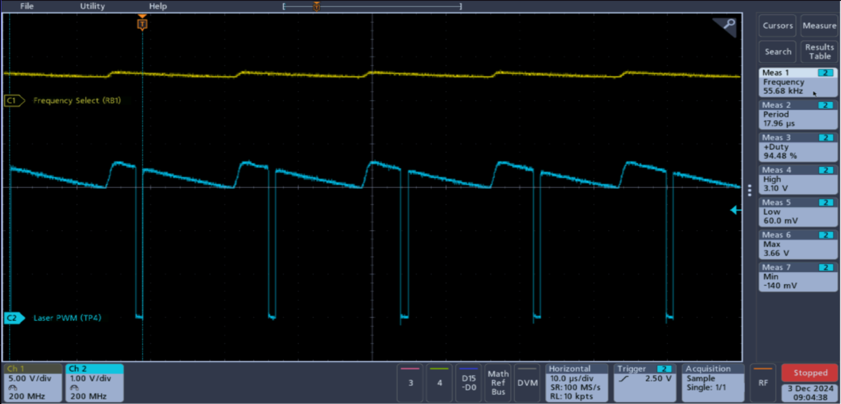

##### Figure 4.2.2: 56kHz PWM Output Frequency Waveform Capture (RB1 = 1)

### 4.2.3: Fire Mode Select

There are 3 fire mode options available on the laser blaster: semi-auto, burst-fire, and full-auto.The user can choose between these modes using SW3, which has three positions and will cause a logic high on RB2, RB3, or neither. The truth table for the inputs’ correlation with the firing mode can be found in Table 4.2.2 below. The timing for the toggling of the outputs is controlled by Timer 1 of the PIC which takes 65 ms to overflow

The semi-automatic or semi-auto mode will fire one pulse each time that the user presses down the trigger. The semi-auto mode is selected with RB2 and RB3 seeing a logic low. Upon the trigger being pressed, the PWM output driver is enabled to turn the laser on for 65 ms. The timing is handled using the PIC’s Timer 1. Upon the trigger being pressed, Timer 1 is reset and the output is enabled. After the 65 ms pulse has ended, as indicated with Timer 1’s interrupt flag, the laser will turn off. Regardless of how long the user holds down the trigger, it must be pressed again in order to fire another shot as shown below in Figure 4.2.3.

The burst-fire mode operates the same as the semi-auto mode in principle, with the difference being that it fires 3 shots rather than 1. This mode is selected with RB3 seeing a logic high, with RB2 seeing a logic low. Upon the button being pressed the PWM output driver is enabled for 65 ms, then off for 65 ms, then back on and off until the blaster fires 3 shots. In this mode, a single trigger press will fire 3 shots and no more again until the button is released and then pressed again, as shown in Figure 4.2.4 below.

The third and final firing mode is the fully-automatic, or full-auto mode. This mode is active when RC2 sees a logic high, and RC3 sees a logic low. In this mode, the blaster will continuously toggle the output as was done in the burst-fire mode at 65 ms intervals, but will do so until the user releases the trigger. So, rather than 3 shots, the user can fire a theoretically infinite amount of times with one trigger press, as shown below in Figure 4.2.5.

##### Table 4.2.2: Fire Mode Select Truth Table

| **RB3** | **RB2** | **Fire Mode** |
| --- | --- | --- |
| 0 | 0 | Semi-Auto |
| 0 | 1 | Full-Auto |
| 1 | 0 | Burst-Fire |
| 1 | 1 | Unused |

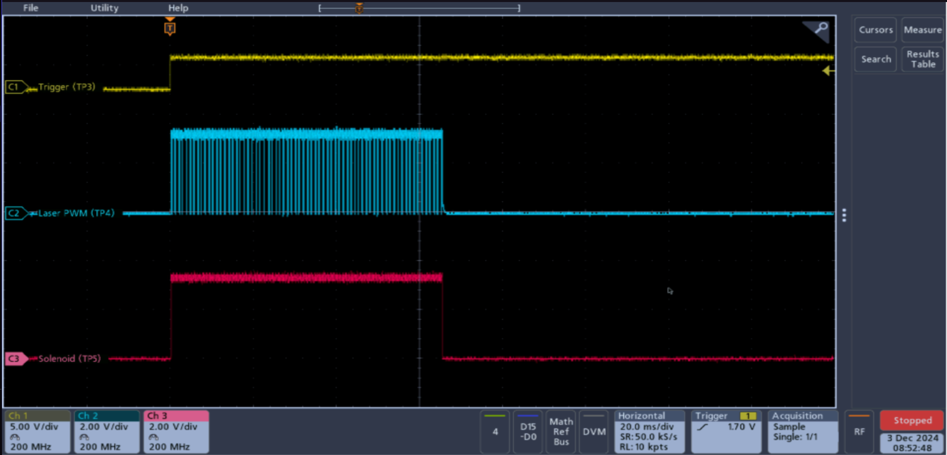

##### Figure 4.2.3: Semi-Auto Fire Mode Waveform Capture (RB2 = 0, RB3 = 0)

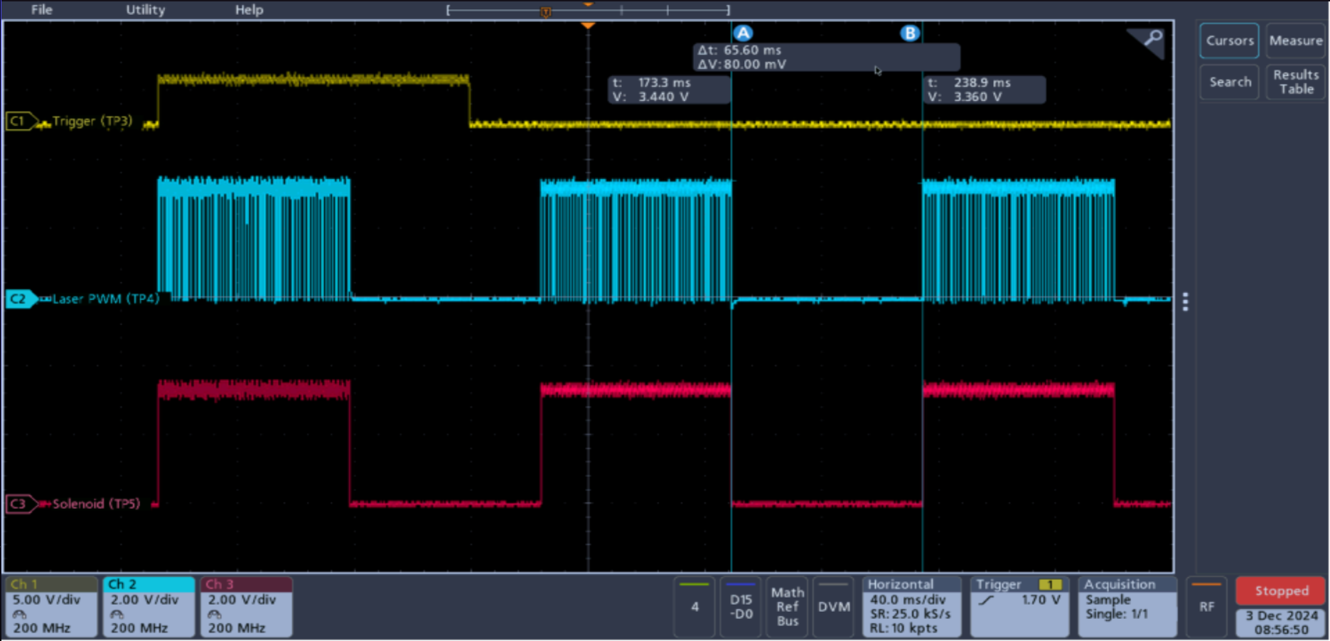

##### Figure 4.2.4: Burst-Fire Fire Mode Waveform Capture (RB2 = 0, RB3 = 1)

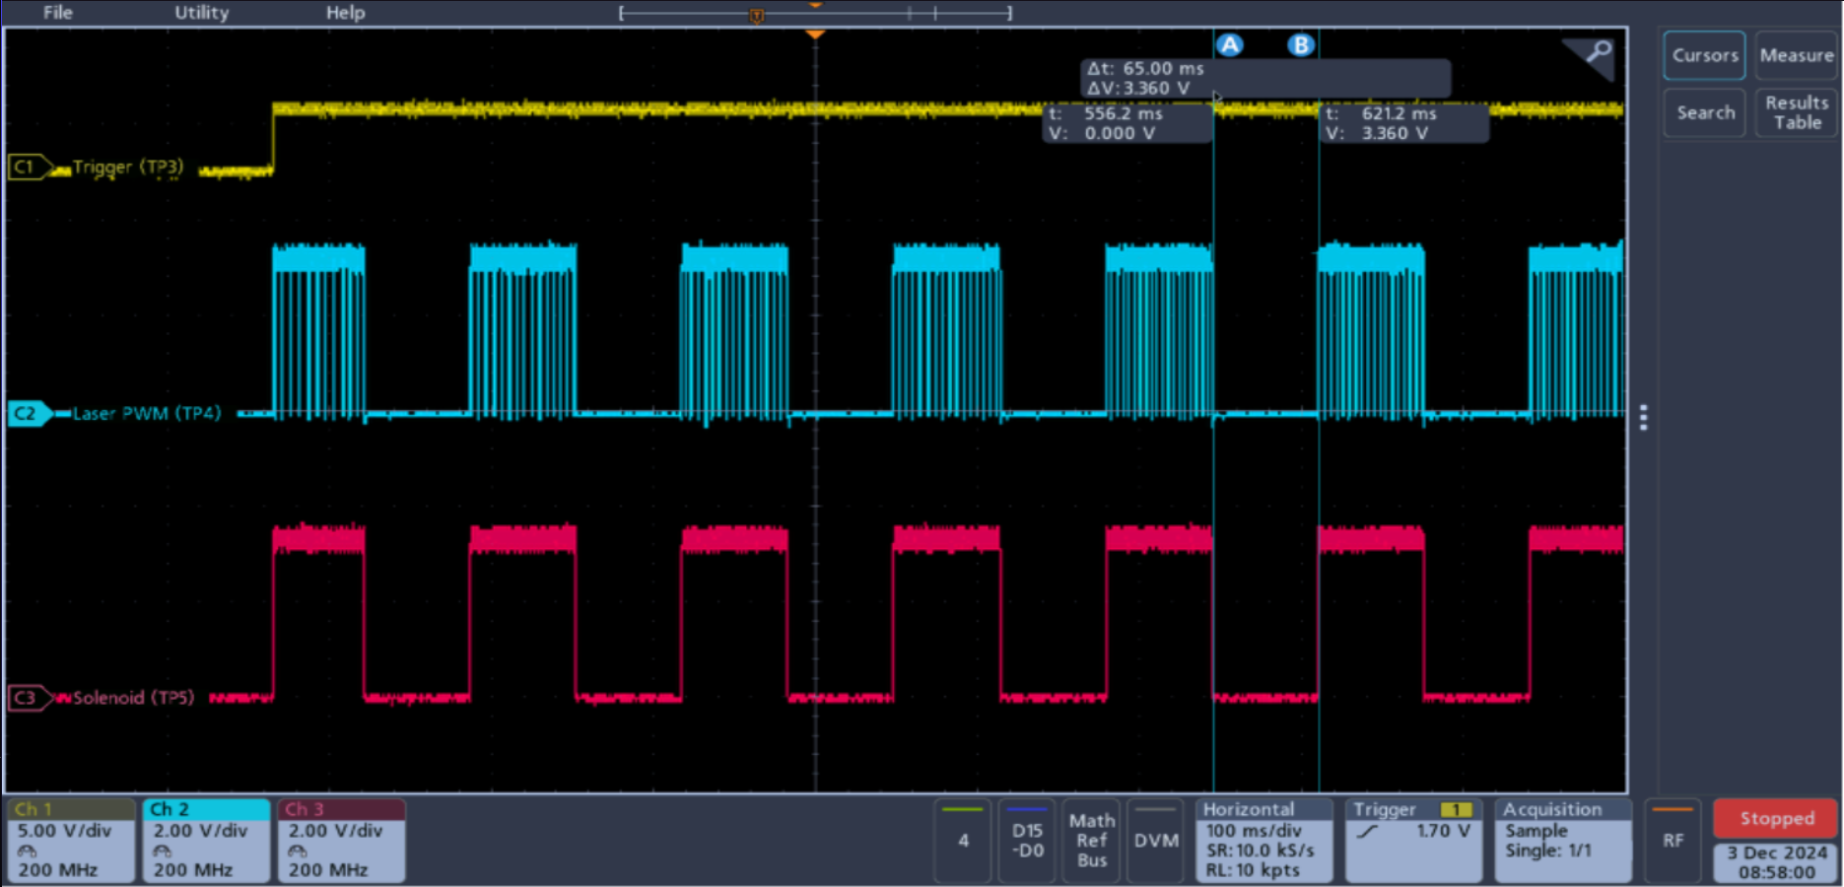

##### Figure 4.2.5: Full-Auto Fire Mode Waveform Capture (RB2 = 1, RB3 = 0)

### 4.2.4: Solenoid Output

A solenoid will be used to push a slide back to simulate the slide of a pistol in the final product. In order to control the solenoid, RC3 is being used to energize the coil with a high or low. A logic high being energized and a logic low being de-energized, and the time that the solenoid is energized will correlate directly with the time that the laser is on, as shown above in Figures 4.2.3, 4.2.4, and 4.2.5.

The solenoid being used currently is rated for 12V/300mA. During testing, the solenoid was being driven with 800mA and operating normally without getting hot since it is on 50% of the time in 65 ms intervals. Since the PIC cannot handle 800mA nor can it handle 12V, a switching transistor darlington pair made from a 2N3904 and a TIP41 was used to allow the PIC to control the solenoid with sufficient current and voltage, without damaging itself.

## 

## 4.3: Blaster Troubleshooting

##### 

##### Figure 4.3.1: Troubleshooting Flowchart

To troubleshoot the blaster, follow through the steps below, which follows along with the flowchart shown above in Figure 4.3.1.

1. Is there +5V on pin 20 of the PIC?
   1. If yes, move to step 4.
   2. If not, move to step 2.
2. Is there +5V on TP2?
   1. If yes, there is a problem between the output of the linear regulator and pin 20 of the PIC.
   2. If not, move to step 3.
3. Is there +12V on TP1?
   1. If yes, there is a problem with the linear regulator.
   2. If not, there is a problem with the battery, or its connections to the circuit.
4. When pressing SW1, does the laser turn on?
   1. If yes, move to step 8.
   2. If not, move to step 5.
5. When pressing SW1, does the PWM output on TP7 enable?
   1. If yes, then move to step 6.
   2. If not, then move to step 7.
6. Without pressing SW1, measuring the collector of Q1, is there +5V? Now pressing SW1, does the output change with the PWM enabled?
   1. If yes to both questions, there is a problem with the laser.
   2. If no to either of the questions, there is a problem with Q1.
7. Measuring TP3 without SW1 being pressed, is the input low? Additionally with SW1 pressed, is the input high?
   1. If yes, there is a problem with the PIC, move to step 15.
   2. If no to either of the questions, there is a problem with SW1 and/or the pull-down resistor R1.
8. When pressing SW1, does the solenoid energize as the laser turns on?
   1. If yes, move to step 11.
   2. If not, move to step 9.
9. Measuring TP8, does the output go high as SW1 is pressed?
   1. If yes, move to step 10.
   2. If not, then there is a problem with the PIC, move to step 15
10. Measuring the collector of Q2/Q3, without pressing the SW1 are you measuring 12V? When pressing SW1, does the signal change?
    1. If yes, there is a problem with the solenoid.
    2. If no to either of the questions, there is a problem with the solenoid driver (Q2 and/or Q3).
11. Measuring TP7 and toggling SW2, when pressing SW1 in each position, is the output toggling between 38kHz and 56kHz?
    1. If yes, then move to step 13.
    2. If not, then move to step 12.
12. Measuring TP4, toggle SW2. Is the input a logic low in one position and a logic high in the other position?
    1. If yes, then there is a problem with the PIC, move to step 15
    2. If not, then there is a problem with SW2, and/or its pull-down resistor R2.
13. Does the blaster change between the three firing modes as SW3 is rotated, and SW1 is pressed?
    1. If yes, then the blaster is functioning as intended.
    2. If not, move to step 14.
14. Measuring TP5 and TP6, as you rotate SW3, does it cycle from both low (TP5 = 0, TP6 = 0), one high (TP5 = 0, TP6 = 1), and then the other high (TP5 = 1, TP6 = 0)?
    1. If yes, then there is a problem with the PIC, move to step 15
15. Try reprogramming the PIC, does it program?
    1. If yes, verify functionality starting at step 4. If this still does not work, there is a problem in the program. Fix the code, reprogram, and verify functionality. If it still does not work then there may be something wrong with the board.
    2. If not, move to step 16
16. Reflow the solder to the pins of the PIC to ensure all of the pins are making a good connection to the board, and try reprogramming again. Did it program?
    1. If yes, verify functionality starting at step 4. If this still does not work, there is a problem in the program. Fix the code, reprogram, and verify functionality. If it still does not work then there may be something wrong with the board.
    2. If not, move to step 17.
17. The PIC may be damaged, try replacing the PIC and programming it. Did this work?
    1. If yes, verify functionality starting at step 4. If this still does not work, there is a problem in the program. Fix the code, reprogram, and verify functionality.
    2. If not, then there is something wrong with the board. Check KiCad, fix the issue and try again next semester.

# 

# 5: Target System

## 5.1: Target System Overview

The target system will be constructed of two types of boards, a master and a slave board, communicating via I2C. The master board is responsible for enabling targets, keeping track of each player’s score, as well as updating the display showing the score to the players. The slave board is the physical target board, which receives the laser from the blaster and determines who scores. The slave board target is disabled until the master enables it. The target is enabled when the indicator LEDs which tell the player which targets are active. Once the enabled target is shot, the slave disables the target as well as the indicator LEDs, and reports which player shot the target on the next master read. There can be up to 128 targets with 7-bit addressing. All slave boards will be daisy-chained together, connected to the master using RJ11 cables which supply +5V, GND, and have SCL and SDA lines for I2C communication. The master constantly polls each slave, occasionally writing to one in order to enable that specific slave’s target.

The target system is still in development and has not been tested, however circuits and program flowcharts have been designed to accelerate future development. The schematic for the master can be found in Appendix A: Figure 10.6, the flowchart in Appendix B: Figure 11.2, and the port bitmaps in Appendix C: Tables 12.4-12.6. Additionally the slave schematic for the slave can be found in Appendix A: Figure 10.7, the flowchart in Appendix B: Figure 11.3, and the port bitmaps in Appendix C: Tables 12.7-12.9.

## 5.2: Target Master Circuit Description

### 5.2.1: I2C Communication

The master can communicate with up to 128 slave devices. The slave devices that the master will communicate with is the LK204 LCD display, as well as the target slave PICs. The master will run power, ground, a clock, and data line out to all slave boards via RJ11 connectors. The master will constantly request data back from the slaves while a game is running to determine if a player has scored. If a slave PIC returns no score update, the master will move on to read the next slave device. If a slave does return a score, then the master will then increment that player's score stored in a temporary register, and write to the LCD display to update the displayed player scores.

#### 5.2.1.1: Enabling a Target

Occasionally the Master will enable a target, with the timing determined by Timer 2. Upon TMR2IF being thrown, the master will enable a target by writing the character “E” (0x45) to the slave. Once the master enables a target, it will move on to reading the next slave’s status.

#### 5.2.1.2: Reading a Slave’s Status

When a master reads the status from the slave, it will request one byte of data, to read if a score was reported or not. Currently, only the bits 0 and 1 will be used to indicate if a player scored or not. This can be seen in the truth table below in Table 5.2.1. Upon receiving a byte from a slave that indicates a player has scored, that player’s score is incremented in a general purpose register, and then updates the score on the LCD display, by writing to it through I2C.

##### Table 5.2.1: Truth Table for Slave Read Byte

| **7** | **6** | **5** | **4** | **3** | **2** | **1** | **0** | **Status** |
| --- | --- | --- | --- | --- | --- | --- | --- | --- |
| Unused* | | | | | | 0 | 0 | No Player Scored |
| 0 | 1 | Player 1 Scored |
| 1 | 0 | Player 2 Scored |

*Bits 7:2 of the receive byte from the slave are currently not being used, however there may be an implementation of them in the future to track the time that it takes to hit a target from the time that it turns on, if not then an additional byte may be used for this purpose.

## 5.3: Target Slave Circuit Description

### 5.3.1: Overview

The function of the slave is to handle target information, and report the status of the target back to the master using I2C communication. The slave board receives power, GND, and clock and data lines from the master board using RJ11 connectors. Each slave board is equipped with two RJ11 female connectors so that each slave can be connected to the master by daisy-chaining all of the slave boards together, providing each with power and I2C lines from the master.

### 5.3.2: Target Enable

The target is in standby mode until receiving an “E” (0x45) character from the master via I2C. In standby mode, the player can shoot the target, but will receive no points as the slave ignores all inputs from the receivers until enabled by the master. Upon receiving an “E” from the master, the slave PIC will enable the target in software, and enable RA0 which enables LEDs around the target to indicate to the players that the target is now active. Once a target has been shot, the target and indicator LEDs will be disabled, and a flag will be thrown indicating which of the two players has scored. Then upon the next read from the master, the slave will return a byte telling the master which player scored, and if no player shot the target, it will stay enabled, and indicate that no player has shot it. The logic for this returned byte to the master can be seen in Table 5.2.1.

### 5.3.3: Target Reception

The target determines that it has been shot by one of two IR sensors, one that is 38kHz (TSOP32238), and the other that is 56kHz (TSOP53456). Both sensors are active low, and when shot by a laser matching their frequency, their output will drop to 0V which will be picked up using interrupt-on-change on RC0 and RC1 of the slave PIC. The 38kHz is designated for player 1, so that each time the parabolic target is shot by a 38kHz laser, RC0 will see a change on its pin and register it as a hit, and then disable the target. Upon the next read from the master, the slave will then indicate that player 1 has hit the target. The same is true for player 2’s 56kHz laser triggering RC1, disabling the target and indicating a player 2 hit on the next master read.

### 

# 7: Engineering Log

##### Table 7.1: Alex Wheelock’s Project Engineering Log

| **Date** | **Category** | **Time Started** | **Time Stopped** | **Duration** | **Description** |
| --- | --- | --- | --- | --- | --- |
| 11/1/24 | Research & Blaster Circuit Schematic Design | 10:10 AM | 3:00 PM | 4:50 | Learning how to use CCP for PWM frequency of the laser gun, and designing the circuit in KiCad |
| 11/4/24 | Programming Blaster | 9:30 AM | 3:00 PM | 5:30 | Trying to get the CCP2 PWM module to work on the PIC16F883 |
| 11/5/24 | Programming Blaster & Research | 11:00 AM | 3:00 PM | 4:00 | Starting to move over to the PIC16F1788, setting it up and doing research |
| 11/7/24 | Programming Blaster | 11:00 AM | 3:00 PM | 4:00 | Got PWM to work on the 1788, testing the laser |
| 11/7/24 | Programming Blaster | 11:00 AM | 12:00 PM | 1:00 | Trying to get the laser to fire only when the button is pressed |
| 11/7/24 | Programming Blaster | 1:00 PM | 3:00 PM | 2:00 | Got the laser to fire only when the button is pressed |
| 11/8/24 | Programming Blaster | 11:00 AM | 3:00 PM | 4:00 | Got both frequencies for the PWM working, and am now able to toggle the frequency using a switch |
| 11/11/24 | Programming Blaster | 11:30 AM | 3:00 PM | 3:30 | Working on the different firing modes for the gun |
| 11/12/24 | Programming Blaster | 11:00 AM | 3:30 PM | 4:30 | Working on different firing modes for the gun, got single shot working |
| 11/13/24 | Programming Blaster | 11:00 AM | 3:00 PM | 4:00 | Got single shot working better, got burst fire working, got a solenoid hooked up and working |
| 11/14/24 | Programming Blaster & Code cleanup | 10:00 AM | 3:00 PM | 5:00 | Got the solenoid working with every firing mode, finished controller, worked on cleaning up/commenting code & updating schematic |

##### 

| 11/18/24 | Documentation & Planning target array & scoring | 10:30 AM | 3:00 PM | 4:30 | Figuring out how to setup the target array |
| --- | --- | --- | --- | --- | --- |
| 12/3/24 | Documentation | 10:00 AM | 3:00 PM | 5:00 | Getting pictures together and starting on documentation for the project |
| 12/5/24 | Documentation | 9:00 AM | 12:00 PM | 3:00 | Updating images, designing schematics |
| 12/6/24 | Documentation | 9:00 AM | 3:00 PM | 6:00 | Doing last flow charts, working on report |
| 12/6/24 | Documentation | 6:00 PM | 7:30 PM | 1:30 | Working on report |
| 12/7/24 | Documentation | 12:00 PM | 5:30 PM | 5:30 | Working on report |
| 12/7/24 | Documentation | 10:00 PM | 1:00 AM | 3:00 | Working on report |
| 12/8/24 | Documentation | 12:45 PM | 3:45 PM | 3:00 | Working on report |
| 12/8/24 | Documentation | 6:00 PM | 9:00 PM | 3:00 | Working on report |
| 12/8/24 | Documentation | 11:15 PM | 1:20 AM | 2:10 | Working on report |
| 12/9/24 | Documentation & Presentation | 9:45 AM | 4:15 PM | 6:30 | Working on report, starting presentation |
| 12/9/24 | Presentation | 6:45 PM | 11:00 PM | 4:15 | Working on presentation, practicing presentation |
| 12/10/24 | Presentation | 9:20 AM | 3:00 PM | 5:35 | Cleaning up presentation, practicing presentation |
| 12/10/24 | Presentation | 8:00 PM | 11:00 PM | 3:00 | Practicing presentation |
| 12/11/24 | Documentation | 12:00 PM | 5:00 PM | 5:00 | Cleaning up & finalizing report |
| **Total Hours Worked:** | | | | | **103:20:00** |

##### 

# 8: Cost Analysis

The cost analysis provides each individual item, item cost, and cost per board for each circuit, as well as the cost of labor. Each part number is a link that will take you to the listing used for pricing. Note that total prices do not include any chassis for the boards, nor does it include PCB pricing itself as the PCBs have yet to be designed. The blaster cost $16.15 to build, see Table 8.1. The target master cost $71.40 to build, with the majority coming from the LCD display, see Table 8.2. The target slave cost $7.09 to build, see Table 8.3. The cost in wages was $5,166.50 with 103.33 hours worked at $50/hr, see Table 8.4.

The total build will require two blasters, one master, and a few dozen slaves for the target array. With 36 slaves/targets, the total build cost would be $330.58 (see Table 8.5). Including wages with this total, the project costs $5,261.14 (see Table 8.6).

##### Table 8.1: Blaster Bill of Materials

| **Component Type** | **Value** | **Quantity** | **Part Number** | **Cost/Part(based on 100 QTY)** | **Cost/PCB** |
| --- | --- | --- | --- | --- | --- |
| Capacitor | 10uF | 2 | [187-CL21A106MQFNNNE](https://www.mouser.com/ProductDetail/Samsung-Electro-Mechanics/CL21A106MQFNNNE?qs=sGAEpiMZZMsh%252B1woXyUXj%252BV5GOLijFH83FB2x1Z8J88%3D) | $0.022 | **0.044** |
| Capacitor | 1uF | 3 | [581-KAF21KR71E105KL](https://www.mouser.com/ProductDetail/KYOCERA-AVX/KAF21KR71E105KL?qs=sGAEpiMZZMsh%252B1woXyUXj17cMikWvs6%2FH2Sb2qb3oaE%3D) | $0.12 | **0.36** |
| Capacitor | 50pF | 1 | [791-0805N500J250CT](https://www.mouser.com/ProductDetail/Walsin/0805N500J250CT?qs=ZrPdAQfJ6DN5LhW6Du3x9A%3D%3D) | $0.023 | **0.023** |
| LED | Green | 1 | [710-150080GS75000](https://www.mouser.com/ProductDetail/Wurth-Elektronik/150080GS75000?qs=2kOmHSv6VfQRoTEZVk1mGA%3D%3D) | $0.151 | **0.151** |
| Diode | 1N4148 | 1 | [637-1N4148W](https://www.mouser.com/ProductDetail/Diotec-Semiconductor/1N4148W?qs=OlC7AqGiEDmsbkbAeXQtXg%3D%3D) | $0.031 | **0.031** |
| Pin Header | 1x5 | 1 | [M20-9990546](https://www.mouser.com/ProductDetail/Harwin/M20-9990546?qs=ulE8k0yEMYY8EKyDN9ic6A%3D%3D) | $0.133 | **0.133** |
| Pin Header | 1x2 | 2 | [M20-9990246](https://www.mouser.com/ProductDetail/Harwin/M20-9990246?qs=Jph8NoUxIfWjw4WmyRvzag%3D%3D) | $0.062 | **0.124** |
| Laser | Laser Diode | 1 | [N/A](https://www.ebay.com/itm/134783770111?chn=ps&mkevt=1&mkcid=28&google_free_listing_action=view_item&srsltid=AfmBOoq8_mAQuFLn84YpIALDgCDhoN97kzXhZTRVbOt4xqeIblb3b1nmcqk) | $3.001 | **3.001** |
| Transistor | 2N3904 | 2 | [512-2N3904TA](https://www.mouser.com/ProductDetail/onsemi-Fairchild/2N3904TA?qs=ljbEvF4DwOOn1Ev%2FzRYaoA%3D%3D&srsltid=AfmBOop8ndmF9H_sohNsrWRWebLeqpNuOxqoHPzvDnzNPniiFMOc-EXY) | $0.064 | **0.128** |
| Transistor | TIP41 | 1 | [511-TIP41C](https://www.mouser.com/ProductDetail/STMicroelectronics/TIP41C?qs=ljbEvF4DwOPALsfJVTZHww%3D%3D) | $0.449 | **0.449** |
| Resistor | 2.2KΩ | 1 | [71-CRCW080522K0JNEAC](https://www.mouser.com/ProductDetail/Vishay-Dale/CRCW080522K0JNEAC?qs=sGAEpiMZZMtlubZbdhIBIIZe04wfiaJWBbL3sbYH8Ww%3D) | $0.01 | **0.01** |
| Resistor | 330Ω | 4 | [603-RC0805JR-13330RL](https://www.mouser.com/ProductDetail/YAGEO/RC0805JR-13330RL?qs=sGAEpiMZZMtlubZbdhIBIAQgR8I6PBLBqCd%2F%2F4dOdbE%3D) | $0.009 | **0.036** |
| Resistor | 1kΩ | 1 | [667-ERA-6APB102V](https://www.mouser.com/ProductDetail/Panasonic/ERA-6APB102V?qs=sGAEpiMZZMtlubZbdhIBIJiMSTY83nT4MhkwRno9TZY%3D) | $0.266 | **0.266** |
| Resistor | 40kΩ | 1 | [71-CRCW080540K0FKEA](https://www.mouser.com/ProductDetail/Vishay-Dale/CRCW080540K0FKEA?qs=sGAEpiMZZMtlubZbdhIBIHFHA%252BLjIXreHLT7U6wPlPw%3D) | $0.018 | **0.018** |
| Resistor | 10kΩ | 1 | [791-RMC1/10K1002FTP](https://www.mouser.com/ProductDetail/Kamaya/RMC1-10K1002FTP?qs=sGAEpiMZZMtlubZbdhIBID6%252BysFJiJfHM5LO5gGOkuQ%3D) | $0.008 | **0.008** |
| Solenoid | 12V | 1 | [BM-0530B](https://www.amazon.com/Baomain-Solenoid-Electromagnet-JF-0530B-PushPull/dp/B01K41EZAU/ref=asc_df_B01K41EZAU?mcid=aee7c0b5f052314fb494aa8fef29f520&tag=hyprod-20&linkCode=df0&hvadid=693071814373&hvpos=&hvnetw=g&hvrand=17977727599470158602&hvpone=&hvptwo=&hvqmt=&hvdev=c&hvdvcmdl=&hvlocint=&hvlocphy=1016216&hvtargid=pla-681099435097&psc=1) | $7.49 | **7.49** |
| Switch | Momentary | 1 | [TS-D001](https://www.amazon.com/Momentary-Pushbutton-Switches-Breadboard-Electronic/dp/B09R47N37H/ref=asc_df_B09R42NFGN?mcid=3442987eead832abb6c81ebd9b9579d4&tag=hyprod-20&linkCode=df0&hvadid=693071814373&hvpos=&hvnetw=g&hvrand=480939150989738202&hvpone=&hvptwo=&hvqmt=&hvdev=c&hvdvcmdl=&hvlocint=&hvlocphy=1016216&hvtargid=pla-2064569570158&th=1) | $0.05 | **0.05** |
| Switch | Toggle | 1 | [612-EG1215AA](https://www.mouser.com/ProductDetail/E-Switch/EG1215AA?qs=lc2O%252BfHJPVZHH%2F6aw0qQrA%3D%3D&mgh=1&srsltid=AfmBOopEMrkHxGX4UdpzX8elz9urFUybNPIjN4sw1dhEwoWUcE4Qqqm1HEo) | $0.683 | **0.683** |
| Switch | SP3T | 1 | [2236244](https://www.jameco.com/z/SR2513-43NS-Taiwan-Alpha-4-Poles-3-Positions-Rotary-Switch-300mA-125VAC-Non-Shorting_2236244.html?srsltid=AfmBOopwvkvLpuwx4egc3aAH5Wnlq00kAC8gX99-U831Tm7AaSfFlZ_K2UY) | $0.35 | **0.35** |
| Voltage Regulator | AMS1117-5.0 | 1 | [926-LM1117MPX5.0NOPB](https://www.mouser.com/ProductDetail/Texas-Instruments/LM1117MPX-5.0-NOPB?qs=X1J7HmVL2ZE1O12Qsl7F9g%3D%3D) | $0.543 | **0.543** |
| Microcontroller | PIC16F1788 | 1 | [579-PIC16F1788T-I/SS](https://www.mouser.com/ProductDetail/Microchip-Technology/PIC16F1788T-I-SS?qs=7DhvGWG6CteZbh5vjho%2Fqg%3D%3D) | $2.25 | **2.25** |
| **Total Blaster Board Cost:** | | | | | **$16.15** |

##### 

##### Table 8.2: Target Master Bill of Materials

| **Component Type** | **Value** | **Quantity** | **Part Number** | **Cost/Part(based on 100 QTY)** | **Cost/PCB** |
| --- | --- | --- | --- | --- | --- |
| Capacitor | 10uF | 2 | [187-CL21A106MQFNNNE](https://www.mouser.com/ProductDetail/Samsung-Electro-Mechanics/CL21A106MQFNNNE?qs=sGAEpiMZZMsh%252B1woXyUXj%252BV5GOLijFH83FB2x1Z8J88%3D) | $0.022 | $0.04 |
| Capacitor | 1uF | 3 | [581-KAF21KR71E105KL](https://www.mouser.com/ProductDetail/KYOCERA-AVX/KAF21KR71E105KL?qs=sGAEpiMZZMsh%252B1woXyUXj17cMikWvs6%2FH2Sb2qb3oaE%3D) | $0.12 | $0.36 |
| LED | Green | 1 | [710-150080GS75000](https://www.mouser.com/ProductDetail/Wurth-Elektronik/150080GS75000?qs=2kOmHSv6VfQRoTEZVk1mGA%3D%3D) | $0.151 | $0.15 |
| Diode | 1N4148 | 1 | [637-1N4148W](https://www.mouser.com/ProductDetail/Diotec-Semiconductor/1N4148W?qs=OlC7AqGiEDmsbkbAeXQtXg%3D%3D) | $0.031 | $0.03 |
| LCD Display | LK204-25 | 1 | [891-LK204-25-E](https://www.mouser.com/ProductDetail/Matrix-Orbital/LK204-25-E?qs=sBNdiSg%2FL5WqFSFQuSy%2FbQ%3D%3D) | $67.72 | $67.72 |
| Connector | RJ11 Header | 1 | [649-54601-906001WPLF](https://www.mouser.com/ProductDetail/Amphenol-FCI/54601-906001WPLF?qs=A%252Bwkq3FTowXIf3bXQPL90g%3D%3D) | $0.104 | $0.10 |
| Pin Header | 1x5 | 1 | [M20-9990546](https://www.mouser.com/ProductDetail/Harwin/M20-9990546?qs=ulE8k0yEMYY8EKyDN9ic6A%3D%3D) | $0.133 | $0.13 |
| Resistor | 2.2KΩ | 1 | [71-CRCW080522K0JNEAC](https://www.mouser.com/ProductDetail/Vishay-Dale/CRCW080522K0JNEAC?qs=sGAEpiMZZMtlubZbdhIBIIZe04wfiaJWBbL3sbYH8Ww%3D) | $0.01 | $0.01 |
| Resistor | 10kΩ | 1 | [791-RMC1/10K1002FTP](https://www.mouser.com/ProductDetail/Kamaya/RMC1-10K1002FTP?qs=sGAEpiMZZMtlubZbdhIBID6%252BysFJiJfHM5LO5gGOkuQ%3D) | $0.008 | $0.01 |
| Resistor | 4.7kΩ | 2 | [603-AC0805DR-074K7L](https://www.mouser.com/ProductDetail/YAGEO/AC0805DR-074K7L?qs=sGAEpiMZZMvdGkrng054t7z4BkURc4Lzw%2FMAWC9Wkfg7CDeh%252BzlAvQ%3D%3D) | $0.023 | $0.05 |
| Voltage Regulator | AMS1117-5.0 | 1 | [926-LM1117MPX5.0NOPB](https://www.mouser.com/ProductDetail/Texas-Instruments/LM1117MPX-5.0-NOPB?qs=X1J7HmVL2ZE1O12Qsl7F9g%3D%3D) | $0.543 | $0.54 |
| Microcontroller | PIC16F1788 | 1 | [579-PIC16F1788T-I/SS](https://www.mouser.com/ProductDetail/Microchip-Technology/PIC16F1788T-I-SS?qs=7DhvGWG6CteZbh5vjho%2Fqg%3D%3D) | $2.25 | $2.25 |
| **Total Target Master Board Cost:** | | | | | **$71.40** |

##### Table 8.3: Target Slave Bill of Materials

| **Component Type** | **Value** | **Quantity** | **Part Number** | **Cost/Part(based on 100 QTY)** | **Cost/PCB** |
| --- | --- | --- | --- | --- | --- |
| Capacitor | 1uF | 4 | [581-KAF21KR71E105KL](https://www.mouser.com/ProductDetail/KYOCERA-AVX/KAF21KR71E105KL?qs=sGAEpiMZZMsh%252B1woXyUXj17cMikWvs6%2FH2Sb2qb3oaE%3D) | $0.12 | $0.48 |
| Diode | 1N4148 | 1 | [637-1N4148W](https://www.mouser.com/ProductDetail/Diotec-Semiconductor/1N4148W?qs=OlC7AqGiEDmsbkbAeXQtXg%3D%3D) | $0.031 | $0.03 |
| LED | Red | 16 | [710-150080RS75000](https://www.mouser.com/ProductDetail/Wurth-Elektronik/150080RS75000?qs=LlUlMxKIyB2jdCo7bnfgew%3D%3D) | $0.151 | $2.42 |
| Pin Header | 1x5 | 1 | [M20-9990546](https://www.mouser.com/ProductDetail/Harwin/M20-9990546?qs=ulE8k0yEMYY8EKyDN9ic6A%3D%3D) | $0.133 | $0.13 |
| Connector | RJ11 Header | 2 | [649-54601-906001WPLF](https://www.mouser.com/ProductDetail/Amphenol-FCI/54601-906001WPLF?qs=A%252Bwkq3FTowXIf3bXQPL90g%3D%3D) | $0.104 | $0.21 |
| Transistor | STN851 | 1 | [511-STN851-A](https://www.mouser.com/ProductDetail/STMicroelectronics/STN851-A?qs=ZGWq6n3A68IcJvqLg9%252BYsA%3D%3D) | $0.453 | $0.45 |
| Resistor | 10kΩ | 1 | [791-RMC1/10K1002FTP](https://www.mouser.com/ProductDetail/Kamaya/RMC1-10K1002FTP?qs=sGAEpiMZZMtlubZbdhIBID6%252BysFJiJfHM5LO5gGOkuQ%3D) | $0.008 | $0.01 |
| Resistor | 330Ω | 16 | [603-RC0805JR-13330RL](https://www.mouser.com/ProductDetail/YAGEO/RC0805JR-13330RL?qs=sGAEpiMZZMtlubZbdhIBIAQgR8I6PBLBqCd%2F%2F4dOdbE%3D) | $0.009 | $0.14 |
| Resistor | 4.7kΩ | 1 | [603-AC0805DR-074K7L](https://www.mouser.com/ProductDetail/YAGEO/AC0805DR-074K7L?qs=sGAEpiMZZMvdGkrng054t7z4BkURc4Lzw%2FMAWC9Wkfg7CDeh%252BzlAvQ%3D%3D) | $0.023 | $0.02 |
| IR Receiver | TSOP32238 | 1 | [782-TSOP32238](https://www.mouser.com/ProductDetail/Vishay-Semiconductors/TSOP32238?qs=EABMROi2%2FsKT2FOMevD8qg%3D%3D) | $0.549 | $0.55 |
| IR Receiver | TSOP53456 | 1 | [78-TSOP53456](https://www.mouser.com/ProductDetail/Vishay-Semiconductors/TSOP53456?qs=Zedt2TSEyhhZyPG8LSxNcg%3D%3D) | $0.39 | $0.39 |
| Microcontroller | PIC16F1788 | 1 | [579-PIC16F1788T-I/SS](https://www.mouser.com/ProductDetail/Microchip-Technology/PIC16F1788T-I-SS?qs=7DhvGWG6CteZbh5vjho%2Fqg%3D%3D) | $2.25 | $2.25 |
| **Total Target Slave Board Cost:** | | | | | **$7.09** |

##### 

##### Table 8.4: Labor Bill of Materials

| **Employee** | **Hours Worked** | **Hourly Pay** | **Total Cost/Employee** |
| --- | --- | --- | --- |
| Alex Wheelock | 103.33 | $50 | $5,166.50 |
| **Total Labor Cost:** | | | **$5,160.50** |

##### Table 8.5: Project Build Cost

| **Item** | **Quantity** | **Cost** | **Total Item Cost** |
| --- | --- | --- | --- |
| Blaster | 2 | $16.15 | $32.30 |
| Target Master | 1 | $71.40 | $71.40 |
| Target Slave | 36 | $7.09 | $255.24 |
| **Total Build Cost:** | **$330.58** | | |

##### Table 8.6: Project Total Cost

| **Item** | **Cost** |
| --- | --- |
| Project Build | $330.58 |
| Labor | $5,160.50 |
| **Total Project Cost:** | **$5,261.14** |

# 9: Conclusion

This semester, the focus was to get the coding completed for the blaster and target, as well as understand how all of the project’s pieces will go together. Unfortunately, within the given project time those goals were not met completely. All features for the blaster, hardware and software were designed and tested, and the blaster is in a functional state. The blaster is able to trigger both receivers which will be used as the targets using only the correct frequency for each receiver. However, the target development did not make it past a schematic and flowchart, meaning that the primary focus next semester will be on building a functional target.

## 9.1: Recommendations

Recommendations for future development focus are on the target circuitry to develop a functional prototype, design the circuit boards for all circuits, and design and build the physical components of the project.

The primary focus should be on working on designing a functional target, so that the project can start to come together. A base to start from for the target has been laid out, with the schematics for both the master and slave circuits (Figure 10.6 and Figure 10.7), as well as designed flowcharts for each program (Figure 11.2 and Figure 11.3). No code has been written for either the master or slave, so the master and slave programs will need to be written from scratch.

Once a working prototype for all circuits has been created, the rest of the project needs to be completed. a PCB needs to be designed for the blaster, and target master and slave circuits. Then, once the PCBs have been designed, there needs to be a place to mount the PCBs, so the physical components need to be designed. This includes a pistol design for the blaster, whether this be a modified design such as a Nerf gun, or a new design from scratch. A parabolic target that can mount onto the PCB so that the player does not have to directly shoot the specific IR receiver to score also needs to be created or found. Additionally, there will need to be a place to mount the target PCBs, so a board will need to be cut and have holes cut out, so that the parabolic target and indicator LEDs can poke through and be visible.

# 10: Appendix A (Schematics)

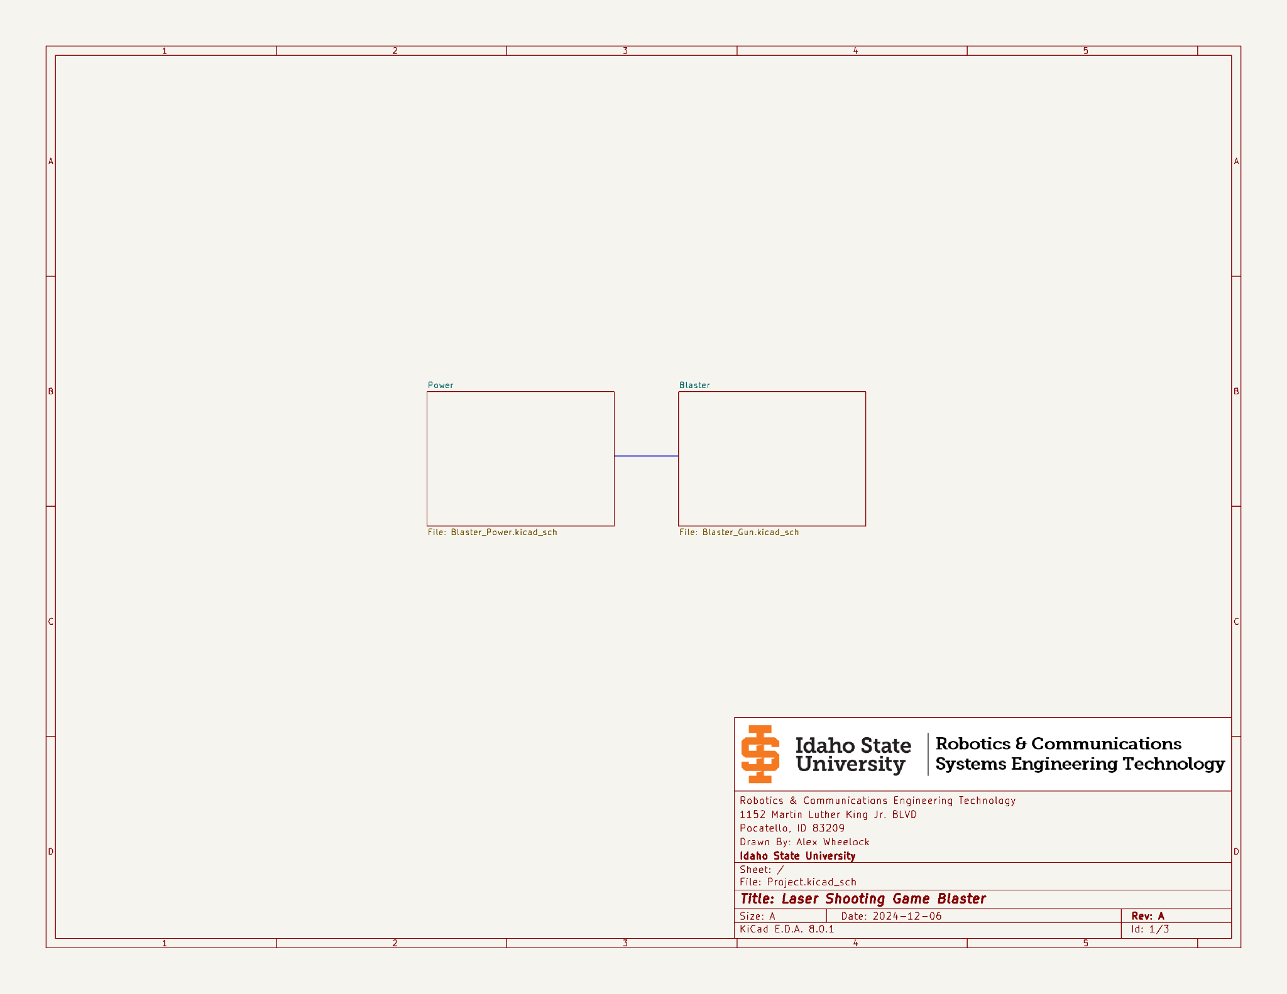

##### Figure 10.1: Blaster Main Schematic Sheet

##### 

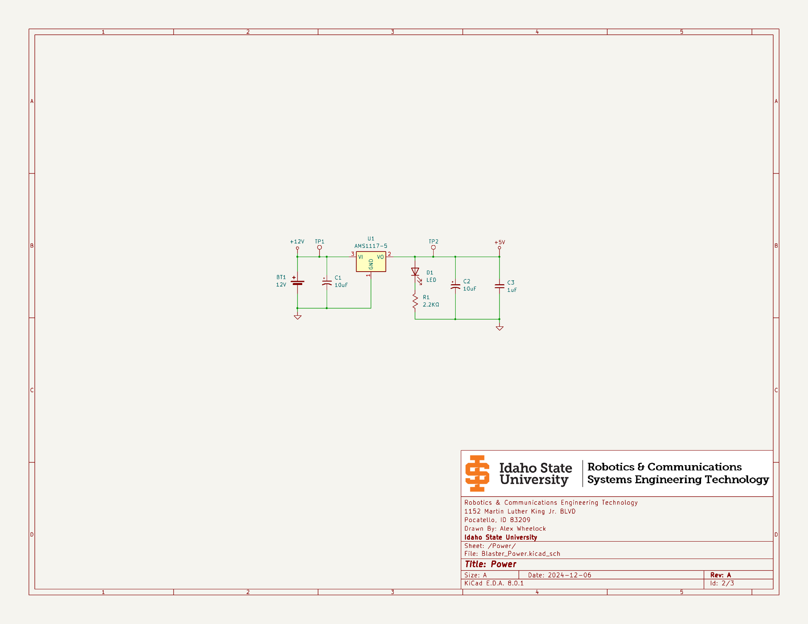

##### Figure 10.2: Blaster Power Schematic

##### Figure 10.3: Blaster Circuit Schematic

##### Figure 10.4: Target Master Main Schematic Sheet

##### Figure 10.5: Target Master Power Schematic

##### Figure 10.6: Target Master Circuit Schematic*

*Target master circuit has not been tested.

##### Figure 10.7: Target Slave Circuit Schematic*

##### 

*Target slave circuit has not been tested.

# 11: Appendix B (Flowcharts)

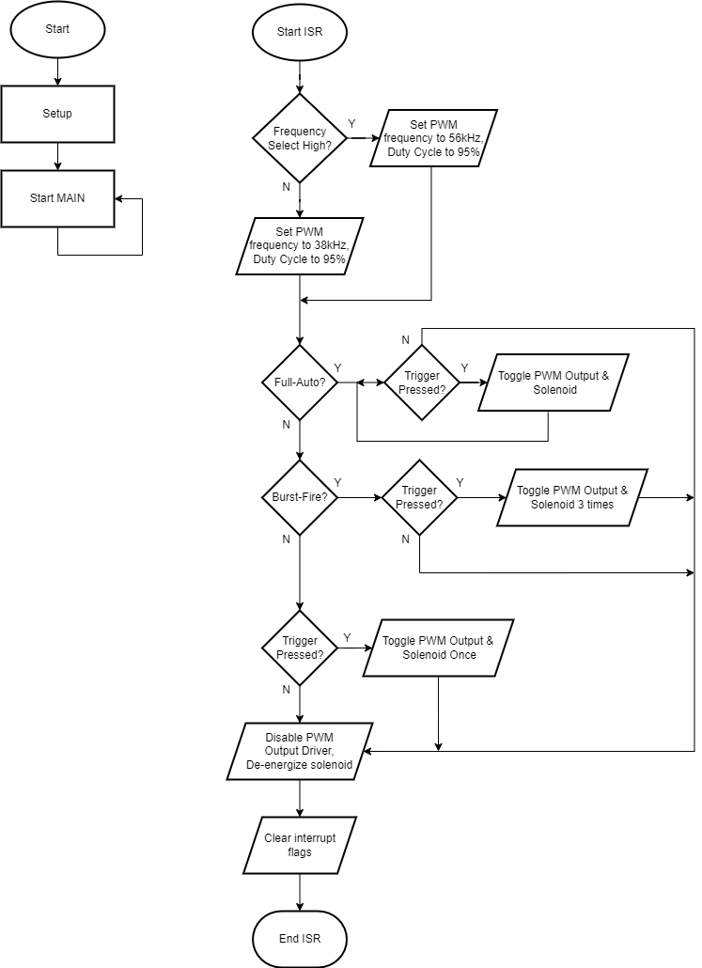

##### Figure 11.1: Blaster Program Flowchart

##### Figure 11.2: Target Master Program Flowchart*

**\***Target master program has not been written and/or tested.

##### Figure 11.3: Target Slave Program Flowchart*

**\***Target slave program has not been written and/or tested.

# 12: Appendix C (Port Bitmaps)

##### Table 12.1: Blaster PORTA Bitmap

| **Bit** | 7 | 6 | 5 | 4 | 3 | 2 | 1 | 0 |
| --- | --- | --- | --- | --- | --- | --- | --- | --- |
| **Function** | Digital Input | | | | | | | |
| **Description** | Unused | | | | | | | |

# 

##### 

##### Table 12.2: Blaster PORTB Bitmap

| **Bit** | 7 | 6 | 5 | 4 | 3 | 2 | 1 | 0 |
| --- | --- | --- | --- | --- | --- | --- | --- | --- |
| **Function** | Digital Input | | | | | | | |
| **Description** | Unused | | | | Used For Fire-Mode Select Inputs | | Used for Frequency Select Input | Used for Trigger Input |

# 

##### 

##### Table 12.3: Blaster PORTC Bitmap

| **Bit** | 7 | 6 | 5 | 4 | 3 | 2 | 1 | 0 |
| --- | --- | --- | --- | --- | --- | --- | --- | --- |
| **Function** | Digital Output | | | | | **\*** | Digital Output | |
| **Description** | Unused | | | | Solenoid Output | PWM Output | Unused | |

**\*** PWM output is constantly changing as the trigger button is pressed, RC2 default is digital input, then upon SW1 being pressed, RC2’s output driver is enabled making it a digital output.

##### 

##### 

##### Table 12.4: Target Master PORTA Bitmap

| **Bit** | 7 | 6 | 5 | 4 | 3 | 2 | 1 | 0 |
| --- | --- | --- | --- | --- | --- | --- | --- | --- |
| **Function** | Digital Input | | | | | | | |
| **Description** | Unused | | | | | | | |

# 

##### 

##### Table 12.5: Target Master PORTB Bitmap

| **Bit** | 7 | 6 | 5 | 4 | 3 | 2 | 1 | 0 |
| --- | --- | --- | --- | --- | --- | --- | --- | --- |
| **Function** | Digital Input | | | | | | | |
| **Description** | Unused | | | | | | | |

# 

##### 

##### Table 12.6: Target Master PORTC Bitmap

| **Bit** | 7 | 6 | 5 | 4 | 3 | 2 | 1 | 0 |
| --- | --- | --- | --- | --- | --- | --- | --- | --- |
| **Function** | Digital Output | | | | | | | |
| **Description** | Unused | | | I2C SDA, for sending/ receiving data from slave devices | I2C SCL, for communi-cating with slave devices | Unused | | |

# 

##### 

##### Table 12.7: Target Slave PORTA Bitmap

| **Bit** | 7 | 6 | 5 | 4 | 3 | 2 | 1 | 0 |
| --- | --- | --- | --- | --- | --- | --- | --- | --- |
| **Function** | Digital Output | | | | | | | |
| **Description** | Unused | | | | | | | Controls Target Enabled Indicator LEDs |

# 

##### 

##### Table 12.8: Target Slave PORTB Bitmap

| **Bit** | 7 | 6 | 5 | 4 | 3 | 2 | 1 | 0 |
| --- | --- | --- | --- | --- | --- | --- | --- | --- |
| **Function** | Digital Input | | | | | | | |
| **Description** | Unused | | | | | | | |

# 

##### 

##### Table 12.9: Target Slave PORTC Bitmap

| **Bit** | 7 | 6 | 5 | 4 | 3 | 2 | 1 | 0 |
| --- | --- | --- | --- | --- | --- | --- | --- | --- |
| **Function** | Digital Output | | | | | | | |
| **Description** | Unused | | | I2C SDA, for sending/ receiving data from the master device | I2C SCL, for communi-cating with the master device | Unused | Used for receiving pulses from 56kHz IR receiver | Used for receiving pulses from 38kHz IR receiver |

# 

# 

# 13: Appendix D (Code)

## 13.1: Blaster Assembly Code

;************************************************************************************

; *

; Filename: Project_Gun.asm *

; Date: November 5, 2024 *

; File Version: 1 *

; Author: Alex Wheelock *

; Company: Idaho State University *

; Description: Assembly file for Laser Shooting Game gun. A gun that can fire *

; a laser at two frequencies (38kHz & 56kHz), with firing mode *

; select (single-shot, three round burst, continuous). Different *

; frequencies will be used to determine between player 1 (38kHz) *

; and 2 (56kHz) for scoring. Gun will use 12V (with solenoid), or *

; 5V (without solenoid), can also use 3.3V if using the LF PIC, *

; with the adjustment of some resistors for the solenoid current. *

; *

; Uses CCP1 (RC2) for laser PWM, RC3 for solenoid control. RB0 for*

; trigger, RB1 for frequency select and RB3:2 used to select from *

; the firing modes. *

; *

;************************************************************************************

;************************************************************************************

; *

; Revision History: *

; *

; 1: Got everything for the gun working the way that I think it should with *

; base features.

; *

;************************************************************************************

#include "p16lf1788.inc" ; processor specific variable definitions

#INCLUDE <16LF1788_SETUP.inc> ; Custom setup file for the PIC16F883 micro-controller

#INCLUDE <SUBROUTINES.inc> ; File containing all used subroutines

LIST p=16lf1788 ; list directive to define processor

errorlevel -302,-207,-305,-206,-203 ; suppress "not in bank 0" message, Found label after column 1,

; Using default destination of 1 (file), Found call to macro in column 1

; CONFIG1

; __config 0xC9A4

__CONFIG _CONFIG1, _FOSC_INTOSC & _WDTE_OFF & _PWRTE_OFF & _MCLRE_OFF & _CP_OFF & _CPD_OFF & _BOREN_OFF & _CLKOUTEN_OFF & _IESO_OFF & _FCMEN_OFF

; CONFIG2

; __config 0xDFFF

__CONFIG _CONFIG2, _WRT_OFF & _PLLEN_ON & _STVREN_ON & _BORV_LO & _LPBOR_OFF & _LVP_OFF

;******************************************

;Interrupt Vectors

;******************************************

ORG H'000' ;BEGINNING OF CODE

GOTO SETUP ;

ORG H'004' ;INTERRUPT LOCATION

GOTO INTERRUPT ;INTERRUPT OCCURRED, RUN THROUGH ISR

;******************************************

;SETUP ROUTINE

;******************************************

SETUP

CALL INITIALIZE ;CALL SETUP INCLUDE FILE

GOTO MAIN ;START MAIN CODE

;******************************************

;INTERRUPT SERVICE ROUTINE

;******************************************

INTERRUPT

BANKSEL PORTB

BTFSC PORTB,1 ;TEST FREQUENCY SELECT SWITCH

GOTO SET_56KHZ ;RB1 IS HIGH, SET PWM FREQUENCY TO 56kHz

GOTO SET_38KHZ ;RB1 IS LOW, SET PWM FREQUENCY TO 38kHz

TEST_MODE

BANKSEL PORTB

BTFSC PORTB,2 ;DETERMINE IF IN CONTINUOUS/FULL-AUTO MODE

GOTO FIRE_CONTINUOUS ;GUN IS IN CONTINUOUS/FULL-AUTO MODE, CHECK IF READY TO FIRE

BTFSC PORTB,3 ;GUN IS NOT IN CONTINUOUS/FULL-AUTO MODE, TEST IF IT IS IN BURST-FIRE MODE

GOTO FIRE_BURST ;GUN IS IN BURST-FIRE MODE, CHECK IF READY TO FIRE

GOTO FIRE_SEMI ;GUN IS NOT IN CONTINUOUS OR BURST-FIRE MODE, DEFAULT TO SEMI-AUTO MODE, TEST IF READY TO FIRE

GOBACK

BANKSEL IOCBF

CLRF IOCBF ;CLEAR PORTB IOC FLAGS

BCF INTCON,IOCIF ;CLEAR IOCIF

BANKSEL PIR1

BCF PIR1,0 ;CLEAR TMR1IF

RETFIE ;RETURN TO MAIN, RE-ENABLE GIE

;******************************************

;Main Code

;******************************************

MAIN

GOTO MAIN ;ENDLESS LOOP, NOTHING HAPPENS (WAITING FOR INTERRUPT)

END

;******************************************

;END PROGRAM DIRECTIVE

;******************************************

## 13.2: Blaster Subroutine Assembly Code

;************************************************************************************

; *

; Filename: SUBROUTINES.inc *

; Date: November 5, 2024 *

; File Version: 1 *

; Author: Alex Wheelock *

; Company: Idaho State University *

; Description: Contains all subroutines needed for the Laser Shooting Game *

; project. Subroutines include the ability to swap between the *

; two player PWM frequencies of 56kHz and 38kHz, and the ability *

; to shoot in three different modes (single-shot, burst, *

; & continuous), to move a solenoid and shoot the laser with the *

; press of a button. *

; *

;************************************************************************************

;************************************************************************************

; *

; Revision History: *

; *

; 1: Initialize file, get everything working the way that I thought it should *

; work. * *

; *

;************************************************************************************

SUBROUTINES_CODE CODE

FIRE_CONTINUOUS

BANKSEL PORTB

BTFSS PORTB,0 ;TEST IF THE TRIGGER IS BEING HELD DOWN

GOTO STOP_FIRING ;TRIGGER IS NOT BEING HELD DOWN, STOP FIRING

BANKSEL TRISC

BTFSC TRISC,2 ;TEST IF OUTPUT DRIVER FOR PWM IS SET OR NOT (FOR ALTERNATING BETWEEN SET/RESET)

GOTO FIRE ;OUTPUT DRIVER WAS NOT ENABLED, ENABLE IT

GOTO _RESET ;OUTPUT DRIVER WAS ENABLED, DISABLE IT

FIRE

BCF TRISC,2 ;ENABLE OUTPUT DRIVER FOR PWM

BANKSEL PORTC

BSF PORTC,3 ;ENERGIZE THE SOLENOID

GOTO CONTINUOUS_CHECK_TIMER ;POLL TIMER 1 FOR TIMING

_RESET

BSF TRISC,2 ;DISABLE OUTPUT DRIVER FOR PWM

BANKSEL PORTC

BCF PORTC,3 ;DE-ENERGIZE THE SOLENOID

GOTO CONTINUOUS_CHECK_TIMER

CONTINUOUS_CHECK_TIMER

BCF PIR1,0 ;CLEAR TMR1IF

POLL_TMR1_CONTINUOUS

BTFSS PIR1,0 ;POLL TMR1IF UNTIL SET, THEN CONTINUE THE CYCLE

GOTO POLL_TMR1_CONTINUOUS ;TMR1 NOT DONE

GOTO FIRE_CONTINUOUS ;TMR1 DONE, REPEAT CYCLE

STOP_FIRING

BANKSEL TRISC

BTFSS TRISC,2 ;DETERMINE IF PWM OUTPUT DRIVER IS ALREADY DISABLED

BSF TRISC,2 ;OUTPUT DRIVER NOT DISABLED, DISABLE OUTPUT DRIVER

BANKSEL PORTC

BCF PORTC,3 ;NO MATTER WHAT, VERIFY THAT THE SOLENOID IS DE-ENERGIZED

GOTO GOBACK ;LEAVE ISR

FIRE_SEMI

BANKSEL IOCBF

BTFSS IOCBF,0 ;DETERMINE IF A TRIGGER PRESS WAS RECORDED

GOTO GOBACK ;DO NOTHING IF NO TRIGGER PRESS

BANKSEL PORTB

BTFSS PORTB,0 ;VERIFY THAT THE BUTTON WAS PRESSED, AND THAT THE INTERRUPT WAS NOT FROM A TRIGGER RELEASE

GOTO STOP_FIRING ;TRIGGER WAS BEING RELEASED FOR THE INTERRUPT, CANCEL EVERYTHING

BANKSEL TRISC

BCF TRISC,2 ;ENABLE OUTPUT DRIVER

BANKSEL PORTC

BSF PORTC,3 ;ENERGIZE SOLENOID

CLRF TMR1L ;/RESET TMR1 FOR FULL TIMING

CLRF TMR1H ;\

BCF PIR1,0 ;CLEAR TMR1IF

POLL_TMR1_SEMI

BTFSS PIR1,0 ;POLL TMR1IF UNTIL COMPLETE

GOTO POLL_TMR1_SEMI ;TMR1 NOT DONE

BANKSEL PORTC

BCF PORTC,3 ;TMR1 DONE, DE-ENERGIZE SOLENOID

GOTO STOP_FIRING ;STOP FIRING

FIRE_BURST

BANKSEL IOCBF

BTFSS IOCBF,0 ;DETERMINE IF A TRIGGER PRESS WAS RECORDED

GOTO GOBACK ;DO NOTHING IF NO TRIGGER PRESS

BANKSEL PORTB

BTFSS PORTB,0 ;VERIFY THAT THE BUTTON WAS PRESSED, AND THAT THE INTERRUPT WAS NOT FROM A TRIGGER RELEASE

GOTO STOP_FIRING ;TRIGGER WAS BEING RELEASED FOR THE INTERRUPT, CANCEL EVERYTHING

BANKSEL TRISC

BCF TRISC,2 ;ENABLE OUTPUT DRIVER FOR PWM

BANKSEL PORTC

BSF PORTC,3 ;ENERGIZE THE SOLENOID

CLRF TMR1L ;/RESET TMR1 FOR FULL TIMING

CLRF TMR1H ;\

BCF PIR1,0 ;CLEAR TMR1IF

POLL_TMR1_BURST1

BTFSS PIR1,0 ;POLL TMR1

GOTO POLL_TMR1_BURST1 ;TMR1 NOT DONE

BANKSEL TRISC

BSF TRISC,2 ;TMR1 IS DONE, DISABLE PWM OUTPUT DRIVER FOR RESET

BANKSEL PORTC

BCF PORTC,3 ;DE-ENERGIZE SOLENOID

BCF PIR1,0 ;CLEAR TMR1IF

POLL_TMR1_BURST2

BTFSS PIR1,0 ;POLL TMR1

GOTO POLL_TMR1_BURST2

BANKSEL TRISC

BCF TRISC,2 ;ENABLE OUTPUT DRIVER FOR PWM (SECOND SHOT)

BANKSEL PORTC

BSF PORTC,3 ;ENERGIZE THE SOLENOID

BCF PIR1,0 ;CLEAR TMR1IF

POLL_TMR1_BURST3

BTFSS PIR1,0 ;POLL TMR1

GOTO POLL_TMR1_BURST3

BANKSEL TRISC

BSF TRISC,2 ;TMR1 IS DONE, DISABLE PWM OUTPUT DRIVER FOR RESET

BANKSEL PORTC

BCF PORTC,3 ;DE-ENERGIZE SOLENOID

BCF PIR1,0 ;CLEAR TMR1IF

POLL_TMR1_BURST4

BTFSS PIR1,0 ;POLL TMR1

GOTO POLL_TMR1_BURST4

BANKSEL TRISC

BCF TRISC,2 ;ENABLE OUTPUT DRIVER FOR PWM (THIRD/FINAL SHOT)

BANKSEL PORTC

BSF PORTC,3 ;ENERGIZE THE SOLENOID

BCF PIR1,0 ;CLEAR TMR1IF

POLL_TMR1_BURST5

BTFSS PIR1,0 ;POLL TMR1

GOTO POLL_TMR1_BURST5

BCF PORTC,3 ;DE-ENERGIZE SOLENOID

GOTO STOP_FIRING

SET_38KHZ

BANKSEL CCPR1L

MOVLW 0x19 ;SET PW TIME FOR 95%DC

MOVWF CCPR1L

BANKSEL PR2

MOVLW 0x19 ;SET PR2 TO 25 FOR 38kHz PERIOD

MOVWF PR2

BANKSEL TMR2

CLRF TMR2 ;RESET TMR2

GOTO TEST_MODE

SET_56KHZ

BANKSEL CCPR1L

MOVLW 0x11 ;SET PW TIME FOR 95%DC

MOVWF CCPR1L

BANKSEL PR2

MOVLW 0x11 ;SET PR2 TO 17 FOR 56kHz PERIOD

MOVWF PR2

BANKSEL TMR2

CLRF TMR2 ;RESET TMR2

GOTO TEST_MODE

## 13.3: Blaster Setup Assembly Code

;************************************************************************************

; *

; Filename: 16LF1788_SETUP.inc *

; Date: November 5, 2024 *

; File Version: 1 *

; Author: Alex Wheelock *

; Company: Idaho State University *

; Description: Firmware for setting up a PIC16LF1788 for the laser gun of the *

; Laser Shooting Game project. *

; *

;************************************************************************************

;************************************************************************************

; *

; Revision History: *

; *

; 1: Initialize file, setup how I think it should be setup for the project. *

; *

;************************************************************************************

;===============================================================================================================================*

; PORTA BITMAP *

;===============================================================================================================================*

; | | | | | | | *

; 7 | 6 | 5 | 4 | 3 | 2 | 1 | 0 *

;---------------|---------------|---------------|---------------|---------------|---------------|---------------|---------------*

;DIGITAL |DIGITAL |DIGITAL |DIGITAL |DIGITAL |DIGITAL |DIGITAL |DIGITAL *

;INPUT |INPUT |INPUT |INPUT |INPUT |INPUT |INPUT |INPUT *

;---------------|---------------|---------------|---------------|---------------|---------------|---------------|---------------*

;UNUSED |UNUSED |UNUSED |UNUSED |UNUSED |UNUSED |UNUSED |UNUSED *

; | | | | | | | *

; | | | | | | | *

; | | | | | | | *

;-------------------------------------------------------------------------------------------------------------------------------*

;===============================================================================================================================*

; PORTB BITMAP *

;===============================================================================================================================*

; | | | | | | | *

; 7 | 6 | 5 | 4 | 3 | 2 | 1 | 0 *

;---------------|---------------|---------------|---------------|---------------|---------------|---------------|---------------*

;DIGITAL |DIGITAL |DIGITAL |DIGITAL |DIGITAL |DIGITAL |DIGITAL |DIGITAL *

;INPUT |INPUT |INPUT |INPUT |INPUT |INPUT |INPUT |INPUT *

;---------------|---------------|---------------|---------------|---------------|---------------|---------------|---------------*

;UNUSED |UNUSED |UNUSED |UNUSED |INPUT USED FOR |INPUT USED FOR |INPUT USED FOR |INPUT USED FOR *

; | | | |BURST-FIRE |CONTINUOUS/ |THE FREQUENCY |TRIGGER BUTTON *

; | | | |MODE SELECT |FULL-AUTO MODE |SELECT SWITCH | *

; | | | | |SELECT | | *

;-------------------------------------------------------------------------------------------------------------------------------*

;===============================================================================================================================*

; PORTC BITMAP *

;===============================================================================================================================*

; | | | | | | | *

; 7 | 6 | 5 | 4 | 3 | 2 | 1 | 0 *

;---------------|---------------|---------------|---------------|---------------|---------------|---------------|---------------*

;DIGITAL |DIGITAL |DIGITAL |DIGITAL |DIGITAL |DIGITAL |DIGITAL |DIGITAL *

;OUTPUT |OUTPUT |OUTPUT |OUTPUT |OUTPUT |OUTPUT |OUTPUT |OUTPUT *

;---------------|---------------|---------------|---------------|---------------|---------------|---------------|---------------*

;UNUSED |UNUSED |UNUSED |UNUSED |OUTPUT USED TO |OUTPUT USED TO |UNUSED |UNUSED *

; | | | |CONTROL THE |CONTROL THE | | *

; | | | |SOLENOID |LASER | | *

; | | | | | | | *

;-------------------------------------------------------------------------------------------------------------------------------*

INITIALIZE_CODE CODE

INITIALIZE

;*** INTOSC SETUP *******

BANKSEL OSCCON

MOVLW 0xEA ;ENABLE INTOSC, SET TO 4MHz

MOVWF OSCCON

BANKSEL CLKRCON

CLRF CLKRCON ;DISABLE CLOCK REFERENCE

;*** SFR SETUP **********

;*** SET OPTION_REG: ****

BANKSEL OPTION_REG

BCF OPTION_REG, PS0 ;\\

BCF OPTION_REG, PS1 ; >>PRESCALER RATIO SET 1:1

BCF OPTION_REG, PS2 ;//

BSF OPTION_REG, PSA ;PRESCALER ASSIGNED TO WDT

BCF OPTION_REG, TMR0SE ;TMR0 EDGE SET RISING

BCF OPTION_REG, TMR0CS ;TMR0 CLOCK SOURCE SET TO INTERNAL

BSF OPTION_REG, INTEDG ;RB0/INT SET TO RISING EDGE

BSF OPTION_REG, NOT_WPUEN ;WEAK PULL UP ENABLED

;*** SET INTCON REG: ****

BANKSEL INTCON

BSF INTCON, IOCIE ;ENABLE IOC INTERRUPT

BCF INTCON, INTE ;DISABLE INT EXTERNAL INTERRUPT

BSF INTCON, PEIE ;ENABLE PERIPHERAL INTERRUPTS

BSF INTCON, GIE ;ENABLE ALL UNMASKED INTERRUPTS

;*** SET PIE1-4 REG: *****

BANKSEL PIE1

MOVLW 0x01

MOVWF PIE1 ;DISABLE ALL PIE1 INTERRUPTS, EXCEPT TMR1IE

BANKSEL PIE2

CLRF PIE2 ;DISABLE ALL PIE2 INTERRUPTS

BANKSEL PIE3

CLRF PIE3 ;DISABLE ALL PIE3 INTERRUPTS

BANKSEL PIE4

CLRF PIE4 ;DISABLE ALL PIE4 INTERRUPTS

;*** CLEAR INTERRUPT FLAGS ***

BANKSEL PIR1

CLRF PIR1 ;CLEAR ALL PIR1 INTERRUPT FLAGS

BANKSEL PIR2

CLRF PIR2 ;CLEAR ALL PIR2 INTERRUPT FLAGS

BANKSEL PIR3

CLRF PIR3 ;CLEAR ALL PIR3 INTERRUPT FLAGS

BANKSEL PIR4

CLRF PIR4 ;CLEAR ALL PIR4 INTERRUPT FLAGS

;*** SET CCP1CON REG: **

BANKSEL TRISC

BSF TRISC,2 ;DISABLE PWM OUTPUT DRIVER FOR CCP1 SETUP

BANKSEL CCP1CON

MOVLW 0x0C

MOVWF CCP1CON ;SELECT PWM MODE FOR CCP1

BANKSEL CCPR1L

MOVLW 0x19 ;PW FOR INITIALIZING 95%DC AT 38kHz

;MOVLW 0x11 ;PW FOR INITIALIZING 95%DC AT 56kHz

MOVWF CCPR1L

;*** TIMER 1 SETUP *****

BANKSEL T1CON

MOVLW 0xA8 ;ENABLE & SELECT TMR1 LP OSCILLATOR, SET PRESCALE TO 1:4, DISABLE TMR1 AT THIS POINT

BANKSEL T1GCON

CLRF T1GCON ;DISABLE TMR1 GATE

;*** TIMER 2 SETUP *****

BANKSEL T2CON

CLRF T2CON

BANKSEL PR2

MOVLW 0x19 ;SET PR2 TO 25 FOR 38kHz PWM FREQUENCY

;MOVLW 0x11 ;SET PR2 TO 17 FOR 56kHz PWM FREQUENCY

MOVWF PR2

;*** ALTERNATE PIN FUNCTION *****

BANKSEL APFCON1

CLRF APFCON1 ;SELECTS PORT MAPPING

CLRF APFCON2 ;SEE DATASHEET (pg 132-133) FOR MAPPING WITH BOTH CLEARED

;*** PORT A SETUP **** PORT A SET AS LOGIC OUTPUT (NOT USED)

BANKSEL PORTA

CLRF PORTA ;CLEAR PORTA

BANKSEL LATA

CLRF LATA ;CLEAR LATA

BANKSEL TRISA

MOVLW 0xFF

MOVWF TRISA ;SET PORTA ALL AS INPUT

BANKSEL ODCONA

CLRF ODCONA ;DISABLE PORTA OPEN-DRAIN

BANKSEL ANSELA

CLRF ANSELA ;SET PORTA ALL AS DIGITAL INPUT

BANKSEL SLRCONA

CLRF SLRCONA ;SET THE SLEW RATE FOR PORT A TO MAXIMUM

;*** PORT B SETUP **** PORT B USED AS LOGIC INPUT

BANKSEL PORTB

CLRF PORTB ;CLEAR PORTB

BANKSEL LATB

CLRF LATB ;CLEAR LATB

BANKSEL TRISB

MOVLW 0xFF

MOVWF TRISB ;SET PORTB ALL AS INPUTS

BANKSEL ODCONB

CLRF ODCONB ;DISABLE PORTB OPEN-DRAIN

BANKSEL ANSELB

CLRF ANSELB ;MAKE PORTB DIGITAL INPUTS

BANKSEL SLRCONB

CLRF SLRCONB ;SET THE SLEW RATE FOR PORT B TO MAXIMUM

BANKSEL IOCBP

MOVLW 0x0F ;ENABLE PORTB IOC FOR POSITIVE EDGES ON RB3:0

MOVWF IOCBP

BANKSEL IOCBN

MOVLW 0x0E ;ENABLE PORTB IOC FOR NEGATIVE EDGES ON RB3:1

MOVWF IOCBN

BANKSEL INLVLB

CLRF INLVLB ;SET PORTB INPUT THRESHOLD TO TTL (IGNORED NOISE BETTER FOR TRIGGER INPUT)

;*** PORT C SETUP ****

BANKSEL PORTC

CLRF PORTC ;CLEAR PORTC

BANKSEL LATC

CLRF LATC ;CLEAR LATC

BANKSEL TRISC

MOVLW 0x00

MOVWF TRISC ;SET PORTC ALL AS OUTPUTS

BANKSEL ODCONC

CLRF ODCONC ;DISABLE PORTC OPEN-DRAIN

BANKSEL ANSELC

CLRF ANSELC ;MAKE PORTC ALL DIGITAL I/O

BANKSEL SLRCONC

CLRF SLRCONC ;SET THE SLEW RATE FOR PORT C TO MAXIMUM

;*** BOOT CODE ****

BCF INTCON,0

BANKSEL T1CON

BSF T1CON,0 ;ENABLE TIMER 1

BANKSEL T2CON

BSF T2CON,2 ;ENABLE TIMER 2

BANKSEL TRISC

BSF TRISC,2 ;DISABLE OUTPUT DRIVER ON STARTUP (WAS ENABLED ON STARTUP WITHOUT THIS)

RETURN ;RETURN TO .asm FILE

# 14: Appendix E (GitHub)

The QR code below (Figure 14.1) will take you to the project repository, where you can download all files for the project, including schematics, PCBs, code, etc.

##### 



##### Figure 14.1: GitHub Laser Game Project Repository